This install tutorial is for people who want to use autoinput script by only using VS2019 without everything.

1. go Tools-> Get Tools and Features

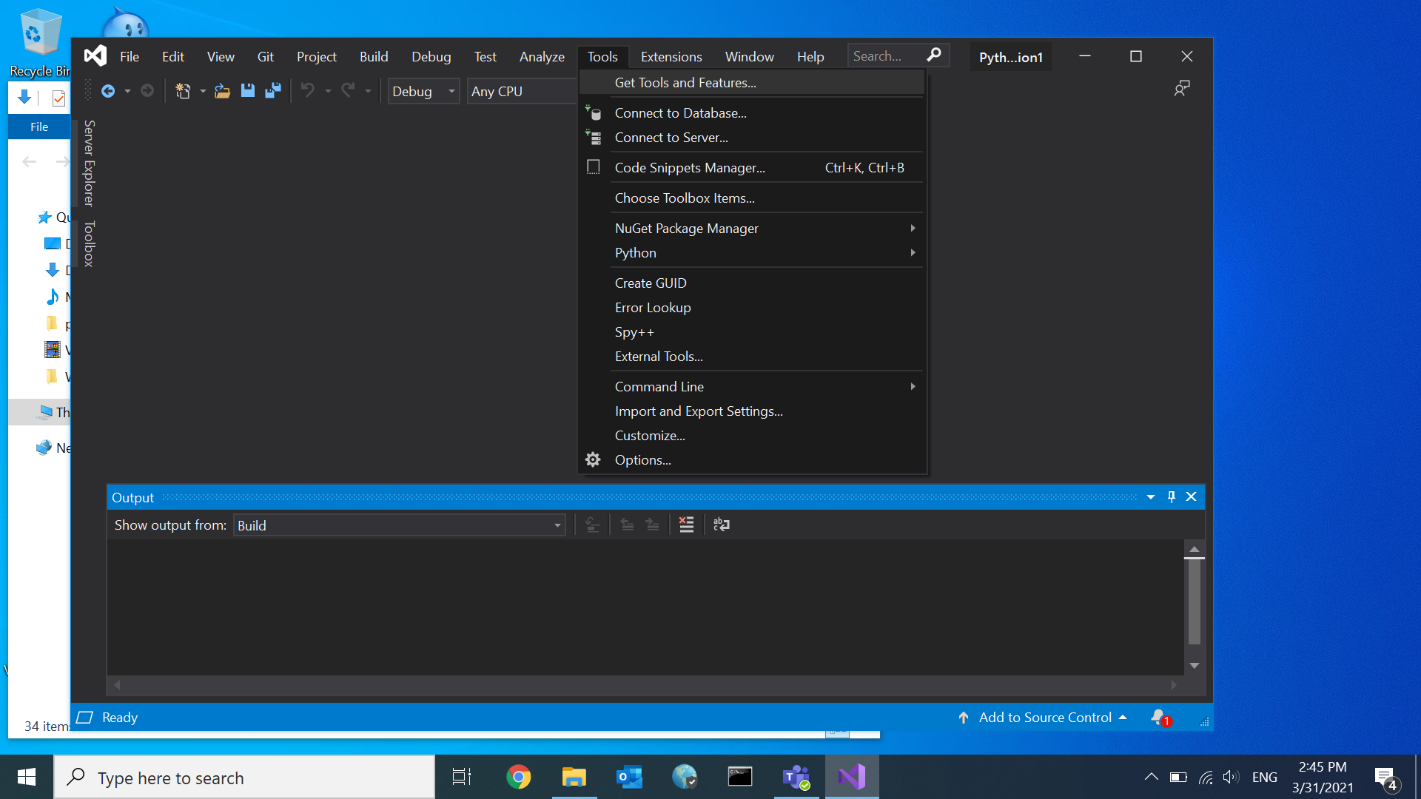

2. Check Python development. And in Installation details, uncheck everything without

Python 3 xx-bit (version), and install it

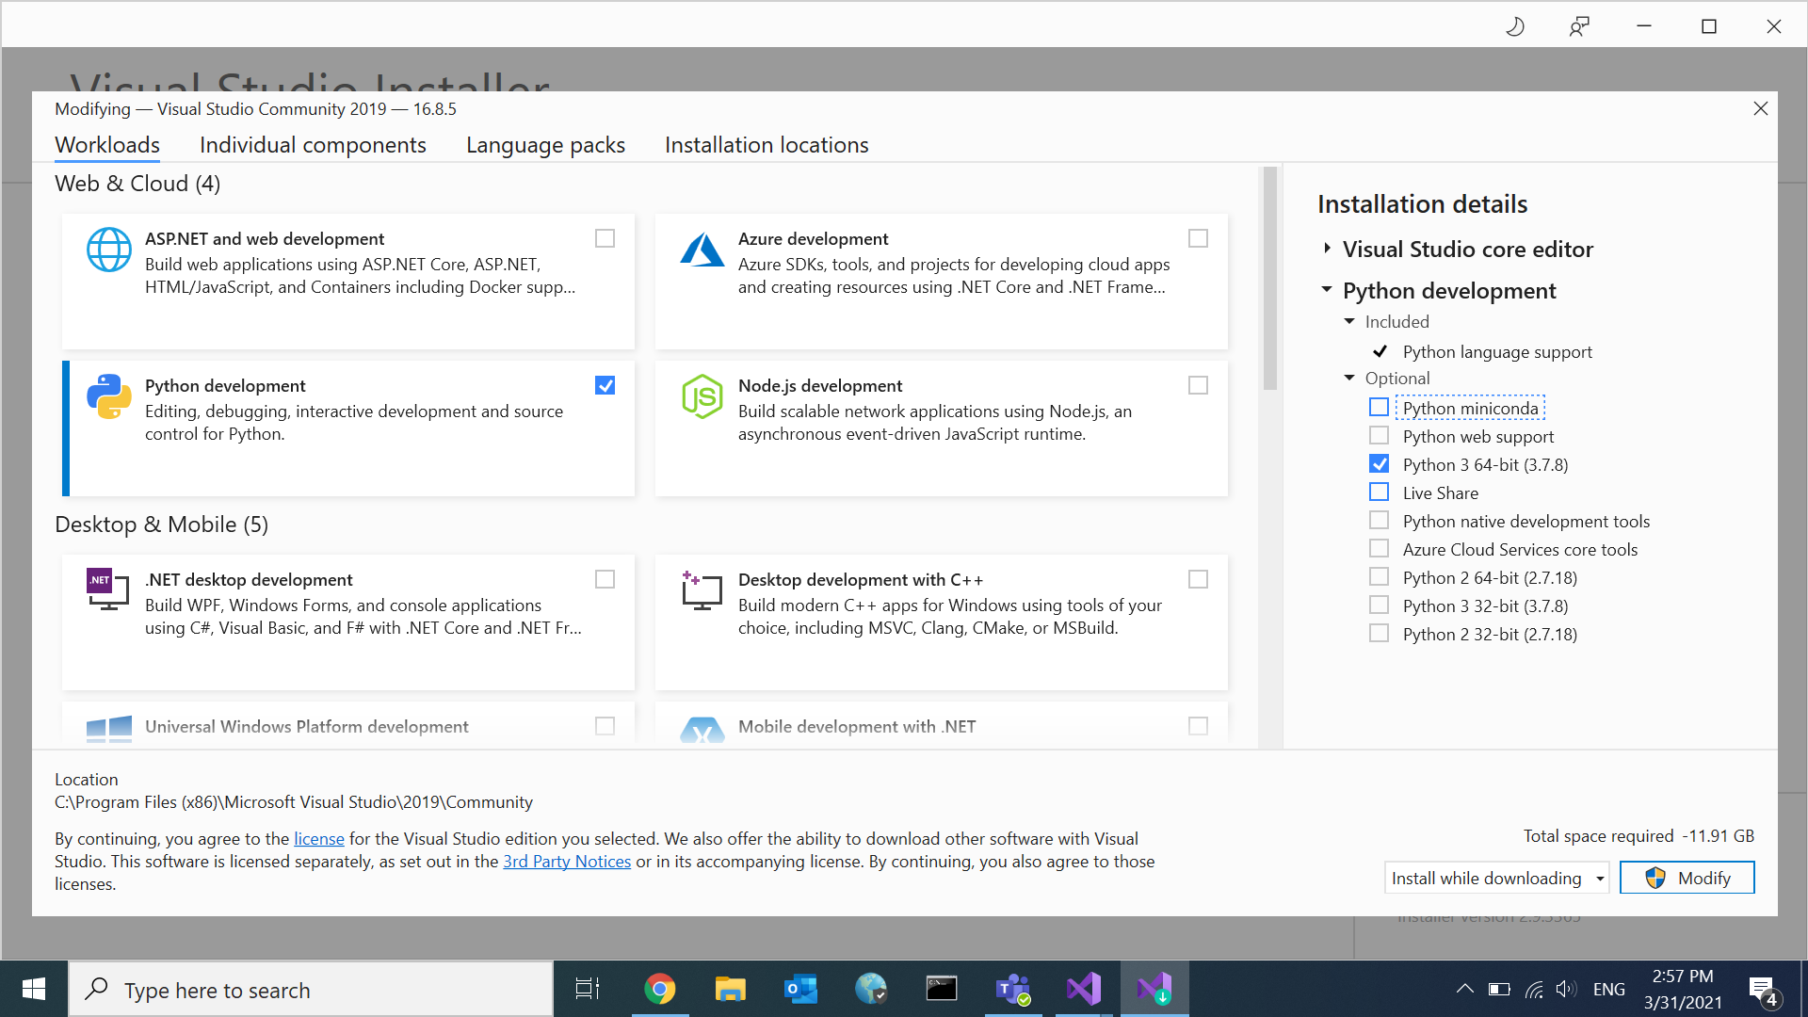

3. go to Tools->Python->Python Environments

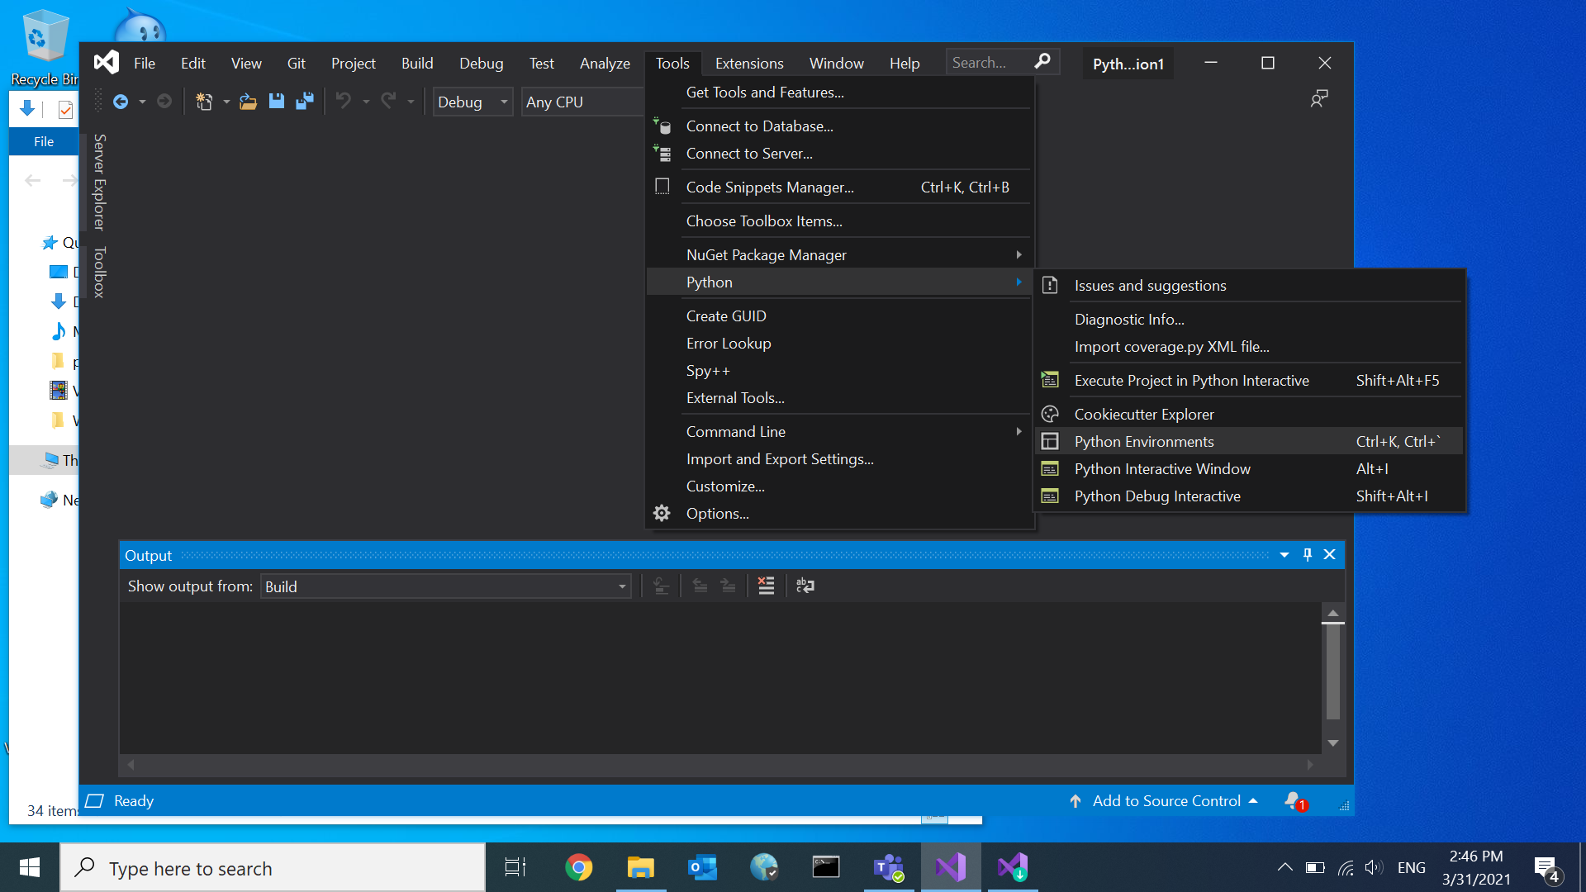

4. Click arrow next to Overview, Click Packages (PyPI)

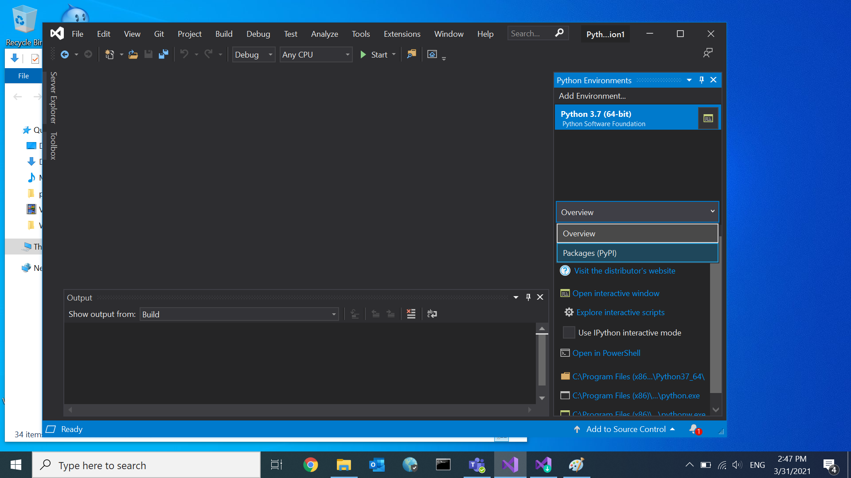

5. Search pyautogui and Click “Run command: pip install pyautogui”

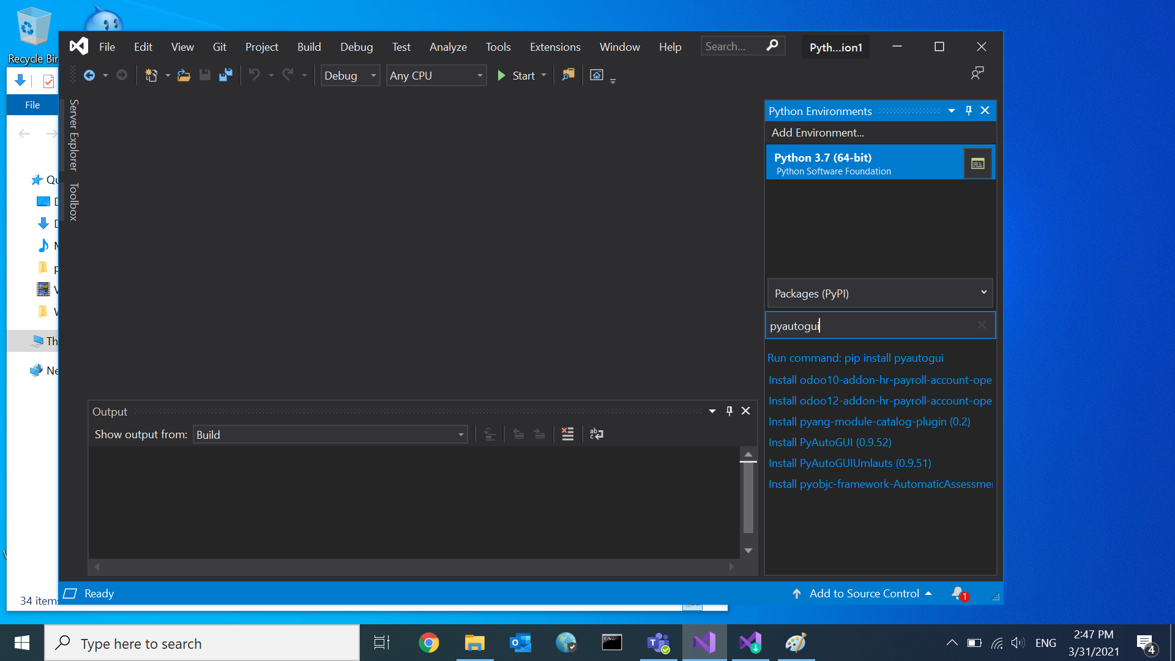

6. Now, you have installed all needed module. Create Python Application

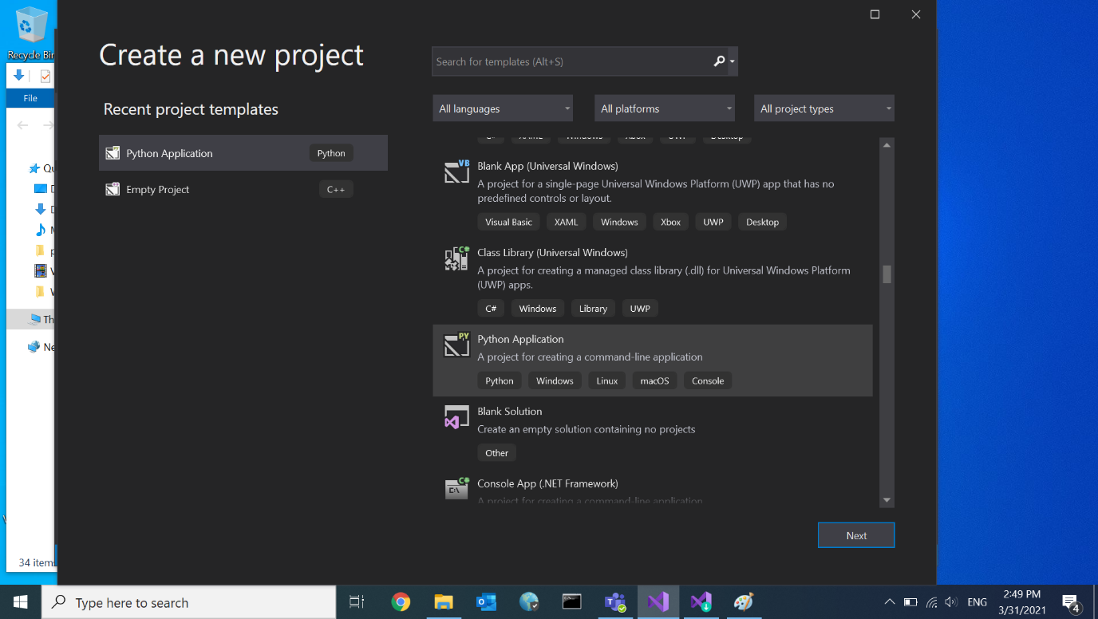

7. Copy and paste autoinput script, and run it!

